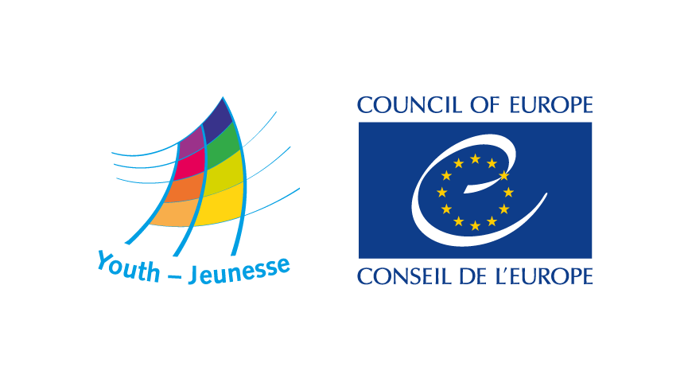

Seminar
Social inclusion of Syrian refugee students
and their role in intercultural dialogue
European Youth Centre, Strasbourg
11-16 July 2016

Application Form

INFORMATION ON THE APPLICANT

1. Surname:
2. First name:
3. Sex: Female Male Other
4. Age:
5. Nationality/ies:
6. Country of residence:

Contacts - Please note all correspondence will be sent to this address – please ensure it is complete*
7. Postal address (street, number, city, postal code, country):

8. Telephone:
9. Mobile telephone:
10. E-mail:

11. Do you have any special needs or requirements (e.g. dietary, disability, etc)?
12. Visas - If you are accepted as a participant in this course, will you require assistance in obtaining a visa to France? If yes, please indicate:
13. Date of birth:
14. Place of birth:
15. Passport No.:
16. Date of Issue of passport or travel document:
17. Date of Expiry of passport or travel document:
18. Document issued at (place):
19. Citizenship as in passport or travel document:

LANGUAGE COMPETENCIES
20. Your native language(s) are:
21. Your level of proficiency in English (Please use the European Language Portfolio scale):

 | A1 | A2 | B1 | B2 | C1 | C2
Understanding
Speaking

22. Other working language(s):

INFORMATION ON THE ORGANISATION (If applicable)
23. Name of sending organisation or institution :
24. Postal address:
25. Telephone:
26. E-mail:
27. Internet address:

28. Please describe briefly the aims of your organisation or institution and main activities related to the topic of the seminar:
29. What is your role in your organisation/institution/formal or informal group/network?

MOTIVATIONS TO ATTEND THE SEMINAR
30. In what ways are you directly concerned by the target group of the seminar (refugees students in Europe)?
31. What is your current legal status in your country of residence?
32. Why would you like to attend the seminar?
33. What would you like to discuss, learn or do during the seminar?
34. What would you like to do after the seminar to support the social inclusion of student refugees?
35. Have you applied for, or attended, any other training course of the Youth Department or of any other service of the Council of Europe in the past two years? If yes, which one(s)? Please specify if applied or participated.

OTHER

36. Are you to attend the full duration of the seminar?
☐ Yes ☐ No (please explain):

37. Any other information relevant for your application:

Please return this application form by 9 June 2016 to
eyc.programme@coe.int

Thank you!

