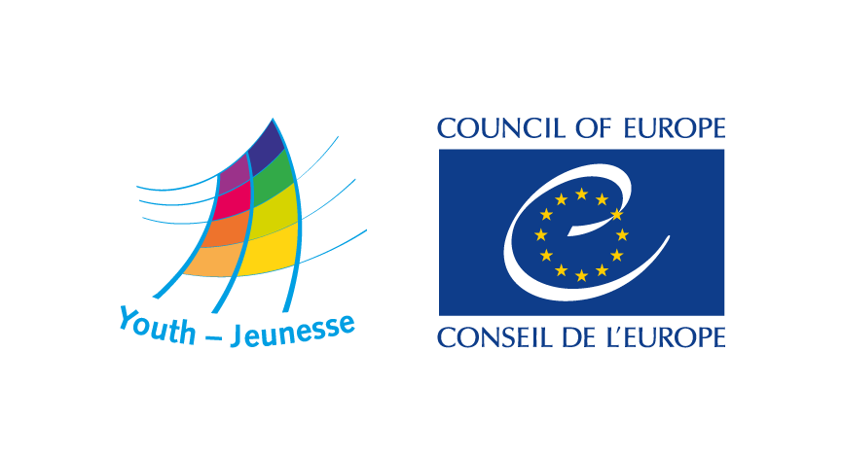

DDCP-YD/ETD (2016) 63 Strasbourg, 30 May 2016

Social inclusion of refugee students
and their role in intercultural dialogue

Seminar
European Youth Centre, Strasbourg
11-16 July 2016

A Joint initiative with the Global Platform for Syrian Students

In cooperation with Kiron - Open Higher Education for Refugees
and the Voice of Young Refugees in Europe

Concept Note
Call for participants

Background and context

The youth policy of the Council of Europe aims at providing young people with equal opportunities and experience which enable them to develop knowledge, skills and competencies to play a full part in all aspects of society. In this mission, a specific attention is paid to vulnerable groups of young people, such as refugees, asylum-seekers and migrants. The Youth for Democracy programme of the Youth Department for 2016-2017 foresees several activities with youth organisations in this domain.

In October 2015, the Joint Council on Youth adopted a Statement on the refugee crisis in Europe which highlights some priorities and calls for special attention to particular vulnerable groups. In this statement, the Joint Council:

reminds the relevant Council of Europe bodies to encourage national governments and civil society organisations to be mindful of the fundamental importance of education as a means of addressing and tackling discrimination, segregation and marginalisation, as well as promoting the values of tolerance, respect and dignity;

recalls the Council of Europe Youth Department’s on-going work to provide young people, including young refugees and asylum seekers, with capacity building opportunities to achieve inclusive and peaceful societies, as well as the European Youth Foundation’s pilot programme, and calls for support for these efforts;
(…)

The Youth Department has been particularly active in drawing attention to the situation of unaccompanied minors and young refugees in transition to adulthood.

In 2011 and 2012 it organised two consultative meetings on the ‘challenges faced by young refugees and asylum seekers in accessing their social rights and their integration, while in transition to adulthood’. Shared experiences in those meetings made very clear that policies addressing the needs of refugees and asylum seeking children do not correlate with other refugees and asylum-seekers policies in a given country. The challenges of unaccompanied and separated refugee and asylum-seeking children are generally acknowledged, but young refugees and asylum-seekers between 18 and 25 are however not acknowledged as a group with specific needs and the transition from one migrant policy regime to the next can be particularly harsh.

In 2014 the Parliamentary Assembly of the Council of Europe adopted the report and resolution 1996 (2014) “Migrant Children: What Rights as 18?”. Work on the report was supported by the Youth Department and by the UNHCR.

The Youth Department and the UNHCR Representation at the European Institutions in Strasbourg carried out in 2014 a field study on European states practice regarding transition to adulthood of unaccompanied and separated asylum-seeking and refugee children: Unaccompanied and separated asylum-seeking and refugee children turning eighteen:
What to celebrate? The study provides for clear examples of the existing challenges state agencies, NGO’s and Young refugees and asylum-seekers are confronted with. The identified challenges lead to major anxieties among young refugees and asylum-seekers and to the deterioration of their living situation and human and social rights. The lack of access to decent housing, education and/or employment prevents them to acquire (financial) independence and exposes them to the risks of falling victim to criminal organisations involved in drugs trafficking, prostitution and trafficking in human beings. The problem is European wide but in each country different practices, some successful, some detrimental to the well-being of young refugees and asylum-seekers, have evolved.

In November 2015, the Youth Department and the Budapest office of the UNHCR co-organised the regional seminar “What rights and realities at 18?” to develop inter-sectorial cooperation in assisting refugees and asylum-seekers in transition to adulthood. The seminar focused on the needs of Unaccompanied and Separated Asylum seeking or Refugee Children (USASRC). The seminar called for, among others:
- Transparent and clear policies related to age assessment of USASRC
- Inclusive policies related to employment and education for USASRC
- More involvement of NGOs in asylum procedures and access to reception or care centres (…)
In addition to this, a high need was expressed for better and increased cross-sectorial cooperation.

The No Hate Speech Movement campaign has regularly included hate speech targeting refugees and asylum-seekers as an issue for common action. This will also be the case in June 2016, when a common action day being prepared for 20 June. The Joint Council on Youth has also prioritised this theme for the campaign in 2016-2017.

The 2016 programme of the European Youth Centres foresees various activities around the theme of young refugees, including a study session with Voice of Young Refugees in Europe on Social inclusion of unaccompanied minors.

Another such activity is the seminar herewith presented, which looks more specifically at the situation and experiences of refugee students in Europe, in particular those from Syria.

The seminar

Refugee students face various challenges in accessing and affording education, integrating in the social and cultural environments and enjoying their rights to freedom from discrimination, expression or association, to name only a few. The recent influx of refugees from Syria has drawn some attention to the harshness and magnitude of these challenges – and their impact on the academic and living environment of the students.

A variety of initiatives across Europe and beyond have mobilised resources and drew the attention of public opinion to the specific needs that student refugees face.
Among them, the Global Platform for Syrian Students acts to provide access to higher education in safe haven countries throughout the world to Syrian students affected by the war. The Global Platform provides emergency scholarships to Syrian students and enables them to acquire professional qualifications.
Another initiative, Kyron - Open Higher Education for Refugees – works to address the 4 main challenges faced by student refugees as identified by the UNHCR: costs, legal matters, capacity and language.

The experiences of these and other initiatives can be utilised to promote the rights of young refugees in general and to advocate for the cause and situation of students in particular. The role of refugee students in also important as mediators and multipliers for intercultural dialogue and help other students and academic environments to peacefully overcome tensions and intercultural misunderstandings. In social contexts sometimes characterised by growing xenophobia and hostility towards refugees it is important that refugees themselves are leading or directly involved in projects for intercultural dialogue.

For the Council of Europe sector, it is important to reach out to refugee students and to identify ways to advocate for their rights and support their social integration through youth work and youth policy projects based on participation and citizenship.

Aims and objectives

The seminar will discuss challenges, identify needs and possibilities for the inclusion of refugee students in Europe and support their role as agents in intercultural dialogue and peace-building. Specific objectives of the seminar are:
- To develop a better understanding of the issues and barriers faced young refugee students in Europe
- To learn from existing experiences and projects and advocate for support to overcome the challenges faced by refugees in accessing education and their social inclusion
- To support refugee students in their role as agents for dialogue and inclusion in their hosting countries and communities
- To identify and propose measures through which youth policy and youth work can support refugee students, notably through Council of Europe youth activities and projects.

The seminar should also result in proposals for consistent follow-up activities and projects by the Council of Europe and its partners regarding refugee students.

Programme elements and methodology

A daily programme is being developed by a preparatory group of the Council of Europe and its partners. The programme will include the following elements:

- Sharing experiences, challenges and solutions
- Getting to know the Council of Europe and its role in relation to students, youth and refugee matters
- Developing contacts with refugee and students organisations in Europe and institutions of potential relevance to their work
- Developing competences on intercultural learning, citizenship and human rights education, conflict transformation and also project planning
- Future planning and network building.

The seminar will be organised and run according to the methodologies and approaches of intercultural learning and non-formal education. The direct experiences and inputs of participants will be particularly valued; they should be at the centre of the programme.

Profile of participants

- Syrian and other refugee students residing in a member state of the Council of Europe, preferably under 30 years of age
- Leaders of youth organisations, and projects working with student refugees or advocating for their rights.
All participants are expected to be genuinely interested in the issues of the seminar and intending to work together to support the participation of refugee students.
The organisers of the seminar will select a total of 20 participants; a particular attention will be paid to ensure equality between men and women in the group of participants.

Practical and financial information

Venue
The seminar will take place in parallel with the Youth Peace Camp 2016, which will be held in July at the European Youth Centre in Strasbourg, France. This would allow for links to be created between the programme and participants of the camp and of the seminar as well as to take advantage of the presence of experts and trainers. The participants will share the living and working space of the European Youth Centre.
Board and lodging will also be provided for all participants at the European Youth Centre.

Dates: 11-16 July 2016

Working language: English

Travel and visa costs
Travel expenses to and from Strasbourg will be reimbursed according to the rules of the Council of Europe. Selected candidates will be informed in due time regarding travel procedures. Visa costs will also be reimbursed by the Council of Europe. The Council of Europe secretariat will issue invitation letter that should facilitate the delivery of visas to attend the conference.

Application procedure
Anyone interested in taking part in the seminar should fill in and return the appended application form to eyc.programme@coe.int by 9 June 2016.

