What’s new for Early Childhood Education and Care? A Council recommendation on high quality and the 2019 Eurydice Key data report – Lunchtime presentation
Photo (comes from Commission AVS):
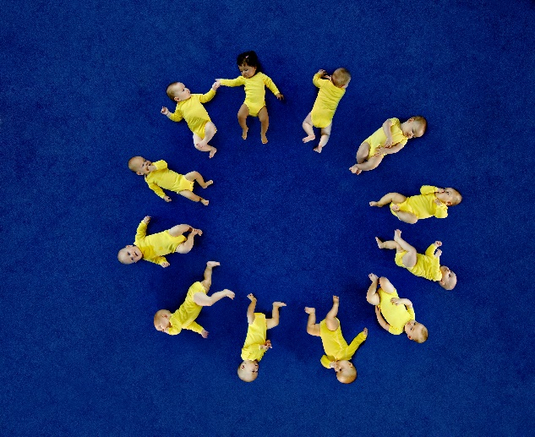
Join us for a lunchtime presentation on 17 September to find out how the EU supports Member States to offer high quality early childhood education and care to all young children and families, from birth to primary school...
Following the European Pillar of Social Rights, which states that “children have the right to affordable early childhood education and care of good quality”, the Council adopted on 22 May 2019 a recommendation on High-Quality Early Childhood Education and Care Systems. In her ‘Agenda for Europe’, president-elect Ursula von der Leyen announced sufficient investment from the European Social Fund+ to improve the quality and accessibility of early childhood education and care systems.
The conference will present the Council recommendation, looking in particular at the EU Quality Framework, which it promotes and at the actions to implement it across Europe, to give the best start in life to all children and families.
To support understanding of the sector and monitor its progress, Eurydice will present the Key Data on ECEC report (2019 edition), highlighting successes and challenges of the various ECEC systems in Europe.
When? 17 September 2019, 12.30-14.00
Webstreaming: https://webcast.ec.europa.eu/presentation-of-the-council-recommendation-and-the-eurydice-key-data-on-early-childhood-education-and-care-17-09-19

